Expert Systems

[Fundamentals of Expert Systems](http://zimmer.csufresno.edu/~sasanr/Teaching-Material/MIS/ES/fundamentals-of-expert-systems.pdf)

<http://zimmer.csufresno.edu/~sasanr/Teaching-Material/MIS/ES/Expert%20Systems-Handouts.pdf>

Sample interview/dialog between the user and the expert system:

User: I am experiencing a problem with my printer.

System: What kind of a problem?

User: The lights keep blinking.

System: What kind of printer do you have?

User: HP DeskJet 920C.

System: Do all lights keep blinking?

User: No; the power light blinks but the cartridge & resume lights are off.

System: Does this happen when the printer is processing a print job?

User: No

System: What you need to do is: ……………………………

All knowledge that CAN be articulated (explicit knowledge) MAY be stated in rules of the form: **IF X, THEN Y**

Knowledge-Base

(Domain Rules)

IF

<Acrobat Reader 6 does not display large images>

THEN

<click Edit/Preferences/Page Display and check the box labeled "*Display large images*">

* symptoms
* conditions
* circumstances
* prescription
* action
* solution

How are Knowledge-Based Systems different from Expert Systems?

**Knowledge-Based Systems: Less Structured**

Knowledge-Base

(Free-Form Text)

** search**

**knowledge**

**response**

Expert/

Specialist

User

**Expert Systems: More Structured**

Knowledge-Base

Domain Rules

“IF …, THEN …”

**[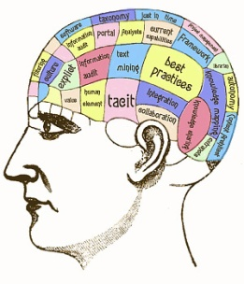](http://www.google.com/url?sa=i&rct=j&q=%22knowledge+Engineer%22&source=images&cd=&cad=rja&docid=a2EcrLQnEpXQfM&tbnid=XQheKR90bTBwZM:&ved=0CAUQjRw&url=http://www.studydiscussions.com/knowledge-management-as-a-career-choice/&ei=dttGUb28GaGfyQHI9IGIAg&bvm=bv.43828540,d.aWM&psig=AFQjCNEY07ON8KQWIORiaAwXViJ8FZ-OxQ&ust=1363684560010428)**

User

Inter-face

** interview knowledge rules**

**advice**

User

Expert/

Specialist

Knowledge Engineer

Inference Engine

Logic Rules

IF X, THEN Y

IF Y, THEN Z

IF X, THEN Z

